Question: Why is .quiz not center

Response: I'll add a short TODO and then patch `styles.css` to center `.quiz`.

Created 2 todos

Now I'll patch the CSS: add `align-items: center` to the `.container` rule so column children are horizontally centered.

Generating patch (14 lines) in [](file:///workspaces/Designing-Tomorrow/frontend/app/styles.css)

```

```
Done — I added `align-items: center` to styles.css. Reason: the container is a column flexbox, so children (including `.quiz`) need `align-items: center` to be horizontally centered. Want me to also make the `.container > div` rule use `width: 100%` for full-width sections instead?

Made changes.

Question: I have an nfc reader which acts as a keyboard. each nfc sticker has an ID which corresponds to a specific animal. I want to be able to scan the animal without the user seeing the ID

Response:
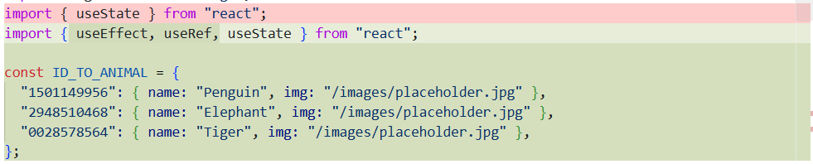
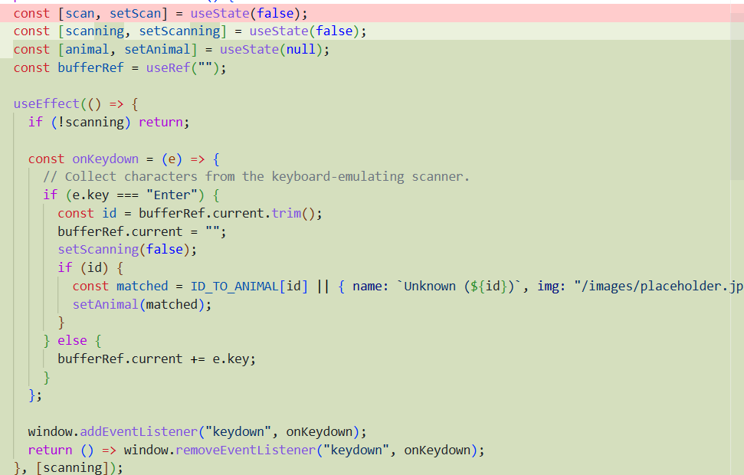
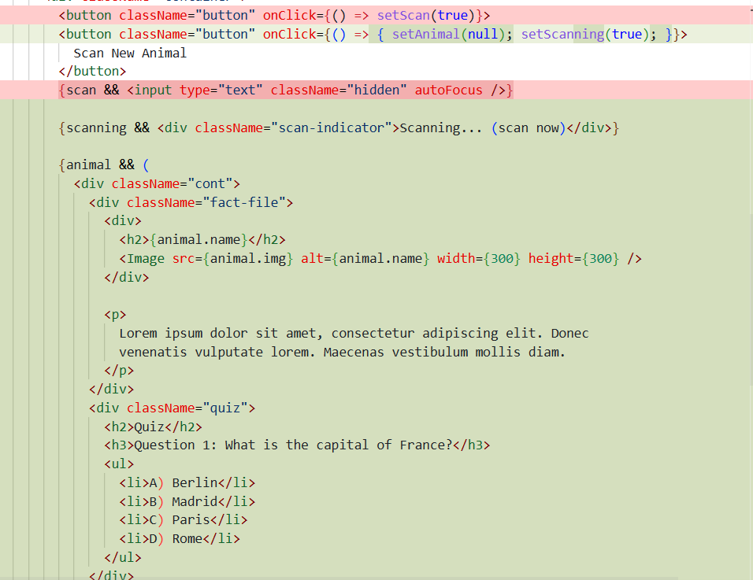
(Quiz is placeholder only)
Question: Add an invisble input so that the ID can actually be inputted.

Response:
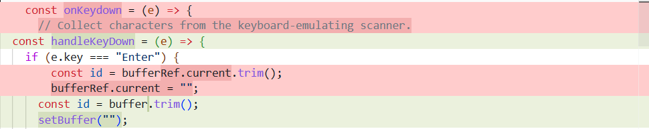
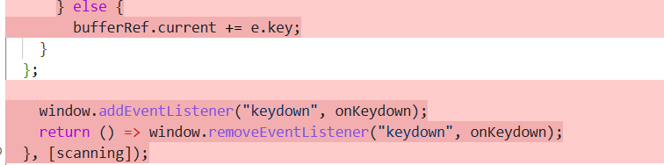
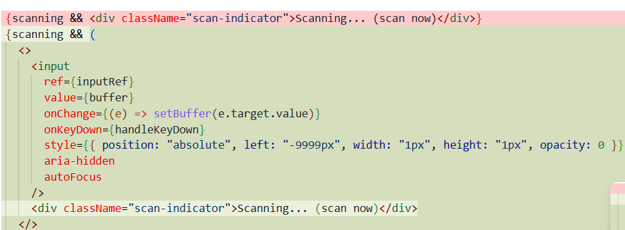
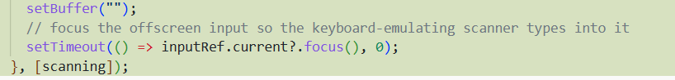
Question: Add the capability to have multiple questions
Answer:

Question: style next, previous, and restart as buttons
Answer:

